Project Design Phase-II
Data Flow Diagram & User Stories
Date | 31 January 2025
Team ID | SWTID-2026-3677
Project Name | Auto Ticket Classification using Flow Designer
Maximum Marks | 4 Marks
Data Flow Diagrams:
A Data Flow Diagram (DFD) is a traditional visual representation of the information flows within a system. A neat and clear DFD can depict the right amount of the system requirement graphically. It shows how data enters and leaves the system, what changes the information, and where data is stored.
Example: (Simplified)  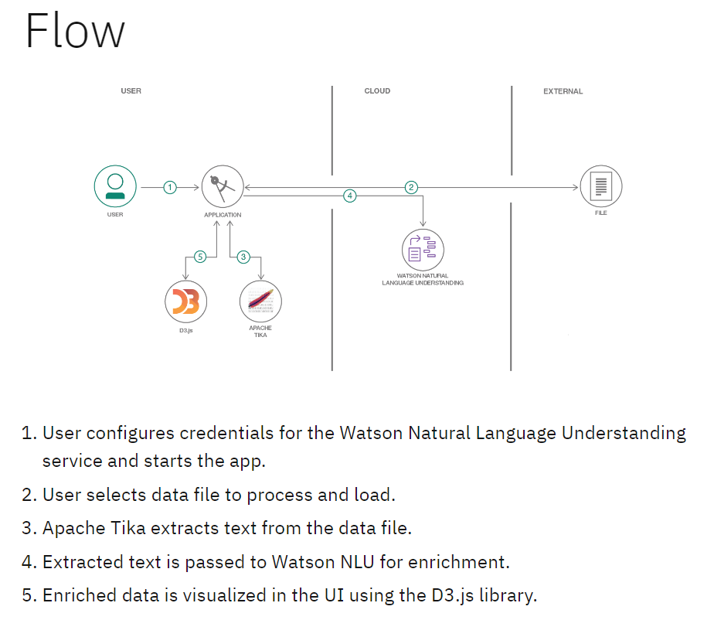 |   

Data Flow Diagram: Auto Ticket Classification using Flow Designer
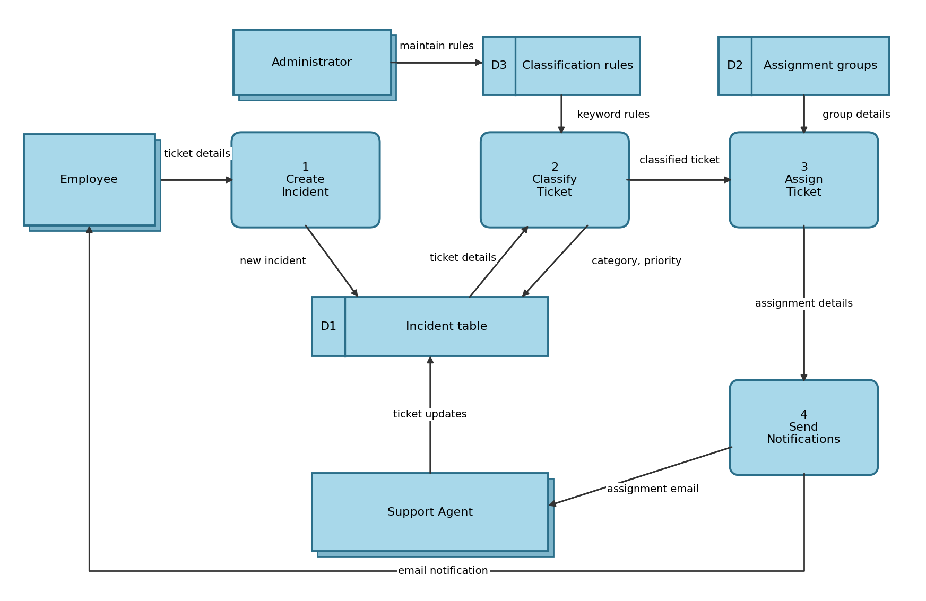

User Stories
Use the below template to list all the user stories for the product.
User Type | Functional Requirement (Epic) | User Story Number | User Story / Task | Acceptance criteria | Priority | Release
Employee (Mobile user) | Ticket Creation | USN-1 | As an employee, I can raise an incident from the ServiceNow mobile app by entering a short description | I can submit the incident and see its number | High | Sprint-1
Employee (Mobile user) | Ticket Creation | USN-2 | As an employee, I will receive an email once my incident is created and assigned | I receive an email with the incident number and assigned group | Medium | Sprint-2
Employee (Web user) | Ticket Creation | USN-3 | As an employee, I can raise an incident through the Service Portal form | The incident is saved and appears in my ticket list | High | Sprint-1
Employee (Web user) | Ticket Tracking | USN-4 | As an employee, I can view the status of my incidents | I can see the category, assignment group and state | Medium | Sprint-2
Service Desk Agent | Ticket Classification | USN-5 | As an agent, I want tickets to be categorized automatically from the short description | Category and priority are set when the incident is created | High | Sprint-1
Service Desk Agent | Ticket Assignment | USN-6 | As an agent, I want tickets to be assigned automatically to the right support group | The incident shows the matching assignment group | High | Sprint-1
Service Desk Agent | Manual Review | USN-7 | As an agent, I can review tickets that could not be classified and correct them | Unclassified tickets appear in a review queue and my changes are saved | Medium | Sprint-2
Administrator | Flow Configuration | USN-8 | As an administrator, I can maintain classification keywords and rules in Flow Designer | Updated rules apply to new incidents | High | Sprint-1
Administrator | Reporting | USN-9 | As an administrator, I can view a dashboard of tickets by category and status | The dashboard shows ticket counts by category and status | Low | Sprint-2
Administrator | Escalation | USN-10 | As an administrator, I want tickets left unassigned to be escalated after a set time | An escalation notification is sent for unassigned tickets | Medium | Sprint-2

